Training and Guidance on Reverse Charge VAT for Construction Businesses

Reverse Charge VAT Starts 1 March 2021

From 1 March 2021 the way VAT is paid between businesses in the construction sector will change. Companies like yours who are VAT registered and CIS registered will no longer pay VAT to most of their subcontractors.
Vat will only be paid by firms in construction to
- firms who supply only labour and are employment businesses AND
- the merchants and businesses that sell building materials without any fix.
The payment of money between firms in the construction chain will pass ‘reverse charged’ and no VAT will be paid.
The purpose of the change is to collect VAT from the few contractors at the top of the construction tree who interface with the customers rather than numerous smaller subcontractors whom HMRC think are less reliable!
The diagram at Appendix 1 shows you the way reverse charge will affect the way money flows in the industry.

What payments are affected by the domestic reverse charge?
After 1 March 2021, a payment must be invoiced/applied for under the reverse charge rules if-
- The payment is for construction services (the definition is the same as for CIS payments –see Appendix 2) and the customer/payer is CIS registered. AND
- Both parties to the contract, the payer and the recipient / the contractor and the subcontractor, are VAT registered AND
- The payment will be standard rated or reduced rated (zero rated supplies continued to be billed as they are now, but no VAT is chargeable because of the zero rate!)
To check whether you should be requesting VAT using a normal invoice or should be reverse charging see Appendix 3.
To check whether an incoming invoice correctly charges VAT or is correct in reverse charging see Appendix 4.

Other Checks
To check whether a customer is VAT registered use the VIES system online.http://ec.europa.eu/taxation_customs/vies/vatResponse.html
To check whether a customer is CIS registered use the same verification system that you use for subcontractors. When you are asked if you have placed an order, simply tick the box to confirm –HMRC has agreed this ‘work around’.
Some customers who are ‘deemed contractors’ because they commission more than one million pounds worth of construction work a year, may not be in the online system.
If you attempt to verify a customer and you cannot not verify them, but they are likely to be a deemed contractor, ask for a letter confirming their UTR, or for a copy of a piece of HMRC correspondence or a printout from their own verification system evidencing their UTR. (You will know that a customer is CIS registered as a contractor or deemed contractor if they have asked you for your details in order to verify you and process any payments to you through their CIS system)

What does a reverse charge invoice look like?
Invoices sent after 1 March 2021 will need to contain wording explaining that they are reverse charge invoices and will look something like this.
They will not show VAT in the columns which calculate the payment to be made. On the following page there is an example invoice where no end user certificate has been supplied.
The example invoice is not prescriptive –legally you do not have to show the VAT number of the customer, but it evidences that you have checked that they are registered and is good practice.
Your software system may not let you calculate the VAT that is being reverse charged and print it outside the accounting column. If you cannot show it, do not worry. The recipient of the invoice will have to do the calculation themselves.
What is important is that your invoice does not charge VAT and clearly shows that it is a reverse charge invoice and S55A applies.

INVOICE
To:  Main Contractor  Address:  Customer VAT Regn. No:  Invoice No:  Invoice Date: |  |  | From: Sub-contractor  Address:  Supplier VAT Regn. No:
Description | Net  £ | VAT Rate |  | VAT  £ | Gross  £
Construction of new housing | 200,000 | 0% |  | 0 | 200,000
Supply of ovens/hobs in new housing | 20,000 | 20% |  | Domestic Reverse Charge Applies | 20,000
Construction of retail premises | 100,000 | 20% |  | Domestic Reverse Charge Applies | 100,000
Non-residential to residential conversion | 150,000 | 5% |  | Domestic Reverse Charge Applies | 150,000
TOTAL | 470,000 |  |  | Payable | 470,000
Customer to account to HMRC for the reverse charge output tax on the VAT exclusive price of items marked ‘reverse charge’ at the relevant rate as shown above. S55A VATA 1994 applies.

What is not covered by the reverse charge –work for end users
An ‘end user ‘is a term used in reverse charge law and needs thought and to be understood
It is a business who will use the building or structure themselves in their own business either as a building to sell, or to rent out, or for their own use e.g., as offices.
Development and property companies and housebuilders are end users because they will rent or sell what they have commissioned. They deal in assets rather than supply construction services.
Another construction business who will add your work to their work and bill everything to a client as construction services is NOT an end user.
In deciding whether you are working for an end user you must ask yourself who you are actually contracted with, who are you expecting to pay you. Do not think about the final client if you will not be directly contracted to or paid by the final client. Ask yourself, is the firm that you work for going to be the end user of that building or construction activity?

Intermediaries and End user Statements
Sometimes you will contract with a group company that is acting for another company in its own group as a property procurement company, it is an intermediary for the end user.
Sometimes you will work for a landlord who is acting for a group of tenants to procure and organise work. The tenants are the end users, and the landlord is an intermediary.
If a business is acting as an intermediary and is VAT registered and CIS registered and the work you are doing is standard rated construction work, you must reverse charge VAT unless the intermediary gives you an end user statement. (IN writing or by email )
Intermediaries acting for groups or for tenants are allowed to issue end user statements. If they give an end user statement there is no need to question it or to enquire about the structure of the group companies, or the landlord tenant contract in any detail –if you hold an end user statement you must charge VAT. (Remember that not many businesses ask to pay VAT!)

Supplies with reverse charge and non-reverse charge elements
Looked at on a contract-by-contract basis a customer is either an end user in a contract or they are not. It is like a light switch, either on or off. If part of a contract is for work that the customer will ‘sell on’ as construction services and where they will not be an end user, this will taint the whole contract and they are NOT an end user of a part. The whole contract must be reverse charged. The customer will be responsible for calculating and paying the VAT due.

In order to simplify some unusual, complicated situations
- If there has already been a reverse charge supply between two parties on a construction site, any subsequent supply on the same site between the same parties can be treated as reverse charge if the parties agree.
- If there are small reverse supplies in a series or bundle of contracts, then the whole series of contracts can be standard rated normally.
- Equally, where there are small supplies which are normally chargeable in a much bigger bundle of supplies, apply the reverse charge to the whole bundle.
The test is that you can ignore small contracts if they are less than 5% by value or volume.
- If there are doubts, and the recipient of the services is VAT and CIS registered and the payments subject to CIS, then a default to reverse charge is acceptable.

What does an end user statement look like? What must it say? Do you need one if it is obvious that the customer is an end user?
Sometimes it will be obvious that the customer is an end user. For example, you are contracted with a manufacturing company to build a factory which they will use, you know the facts and they know the facts. They are an end user.
It is recommended that wording in the contract on the follow lines would be sufficient to amount to an end user statement
The customer/employer confirms that for the purposes of Section 55A VAT Act 1994 reverse charge for building and construction services, it is an end user and should be charged VAT. The customer/employer will inform the contractor promptly if they cease to qualify as an end user.
If wording like this is not in the contract, a letter from the customer/employer using the following words is sufficient.
We are an end user for the purpose of the Section 55A VAT Act 1994 reverse charge for building and construction services. Please issue us with a normal VAT invoice with VAT charged at the appropriate rate. We will not account for the reverse charge.
If end user statements are given to you by customer/employers, you should retain them and know where to find them for the purpose of an audit! Email is acceptable but keep them.
If you ask say twice for an end user statement and fail to get one, reverse charge.
If HMRC find that a customer has failed to notify end user status to their supplier they will require the customer to account for and pay the VAT, exceptionally they may require the customer to contact the supplier and request a corrected invoice.

What if an end user stops being an end user?
The simple position is never look back. The next invoice you issue or application you make will reverse charge, but it will not rework the VAT on earlier invoices or payments nor will you make any attempt to time apportion anything.
How can an end user stop be being an end user? The best way to think about this is to think of an example. Imagine a developer owns a plot of land on which he intends to build a retail park which he will sell as warehouse units. He is an end user because he will sell units, he will not supply construction services to anyone. The builder of the units is supplying construction services, he checks the developer is CIS registered (he is a deemed contractor because he commissions more than one million pounds of construction work a year), he is VAT registered and the supply is standard rated. The builder would normally reverse charge, but the developer gives him an end user certificate.
But then the developer sells the whole site during construction to a major retailer but retains the contract to build the warehousing. He is still the builder’s client, but he is not an end user and he must tell the builder that he is no longer an end user.
At the point he is notified of a change from end user status, the builder simply reverse charges all future invoices, and all payments outstanding. He does not rework historic paid invoices or time apportion anything as partly reverse charge and partly not. What has been done is gone, it is only future invoices, and applications for payment that will be reverse charged and no attempts at correcting the past should be attempted.
(If in the example outlined, the building contract was assigned to the new owner then the new owner is likely to be an end user and should be asked if they wish to supply an end user certificate.)
What if a customer becomes an end user?
If a customer who was being reverse charges suddenly sends an end user certificate you go with the flow! You start charging VAT on the next application for payment, or invoice issued. You do not attempt any historical reworking or time apportioning.

Some special types of Customer
As a rule if you think a customer like a utility company or a local authority is likely to be an end user, always ask them if they would like to give you an end user statement. It does no harm and will prevent a sudden flurry of activity if they suddenly find themselves not billed for VAT when they should have been.
Utility Companies
Supplies of services to utility customers will usually be supplies to end users because the work will be the construction, repair, alteration of the utility companies owns assets. The companies are generally CIS registered so will be end users.
Exceptionally they will not be end users when they take on the role of contractor for a domestic customer to install a central heating system for example, or accept a contract working for a private power network.
Local Authorities
Local authorities are unlikely to be on supplying construction services. The supplies made to them are more likely to be part of works to an authority’s own assets or provided as part of its statutory obligations so it will be normal for them to be end users. Always ask them if they are going to supply you with an end user statement.

What is not covered by the domestic reverse charge –the supply of building materials and the purchase of goods
The supply of building materials only, without any fix, is not within the CIS scheme and so it is not covered by the reverse charge legislation.
When you buy building materials you will be charged VAT normally.
If you buy building materials with any sort of services of fix or install, the contract is covered by CIS and reverse charge may be appropriate.
Caution –a subcontractor cannot simply split the invoice into two, one for materials and one for fix. The CIS scheme and the reverse charge both focus on nature of the supply under the contract. If a contract is for supply and fix it wholly falls within CIS and reverse charge.

The CIS Scheme and VAT reverse charge
Where a subcontractor is gross paid, he will be paid all the money due under the contract. If the VAT is to be reverse charged, he will be paid in full but without VAT.
Where the subcontractor is net paid for CIS, he receives a payment for all his materials but is subject to a 20% deduction on the balance. Where the invoice is to be reverse charged, he is paid no VAT at all (none on the materials because they are part of a supply and fix contract).
Where the invoice is to carry VAT (take care this will be unusual, and will probably be because your firm is itself an end user in the transaction) the whole invoice will be subject to VAT.

Exemptions from the reverse charge -employment businesses
The reverse charge will not apply to payments made to employment businesses/a labour agency which provide you with labour/workers who are paid weekly or monthly by that business. Payments to an employment business will carry normal VAT.
Payments are subject to the CIS scheme -verification, gross or net payment, but they are not to be reverse charged.

Transitional arrangements –invoices, applications for payment and retentions
The reverse charge legislation comes into effect on 1 March 2021.
In VAT there is a concept called the tax point. This is the date which governs when VAT can be claimed or must be accounted for. The normal rule is that in construction the tax point is the earlier of the invoice date or payment date.
If you receive money on or before 28 February 2021 the payment will include VAT. If you receive an invoice dated before 1 March 2021 the invoice must show VAT. But let’s look at invoices, applications, and retentions separately-

Invoices
If an invoice is dated 28 February 2021 or earlier, the reverse charge does not apply, VAT should be shown on the invoice and VAT should be paid even if the payment is made after 1 March 2021.
If an invoice is dated on or after 1 March 2021 and all the conditions for reverse charging are met (Appendix 3 and 4) it should be reverse charged.
For the avoidance of doubt,
- if an invoice is for construction services AND
- not to a labour provider or for building materials AND
- the supplier is VAT registered
the invoice should be reverse charged and if it is not reverse charged it should be returned to the business which issued it with a request to correct it and reissue it as a reverse charge invoice.

Payments in advance of paperwork
If a payment has been made in advance of an invoice and the payment was made in, say, February 2021, the payment is deemed to include VAT (because it has a tax point before the date of change).
If an invoice marked ‘paid’ is sent as a receipt after 1 March 2021 it should be clearly marked ‘Tax point xx February when payment received’ and should show VAT to accord with the payment.
Self-billing invoices and authenticated receipts
HMRC have allowed a three-month concession intended to simplify the introduction of reverse charge for applications for payment /authenticated receipts and self-billing.
When an application for payment is made under a contract which provides for staged payments, the application is not done as an invoice but as a letter.
When a subcontractor agrees to be self-billed, he agrees not to issue an invoice or an application for payment at all.
In both instances, a quantity surveyor/business manager acting for the contractor will agree that the work has been done to payment standard and enter the payment into the paying firm’s system.
The HMRC concession says that if a business has entered a payment into their self-bill/staged payment system as valid for payment, before the 1 March 2021 and pays by 31 May 2021, the payment will carry VAT.
If it is entered into their accounting system on or after 1 March 2021 or is entered before 1 March 2021 but is not paid until after 31 May 2021 (Chaos, loss inefficiency?), it must be reverse charged.

Retention Payments
The rules for reverse charge are the same as the rules for CIS. It does not matter when the work was done, the date which decides whether to reverse charge is the earlier of the invoice date requesting money or the payment date. Ignore when work was actually done!

Accounting the reverse charge
The domestic reverse charge works by making the customer receiving the supplies liable to pay the VAT due to HMRC instead of paying the supplier. BUT it allows the customer to recover the VAT due on the supply subject to normal recovery rules. This means the same amount goes on both sides of the VAT return and costs the customer nothing.
It is to be hoped that all commercial software will automatically enter reverse charge transactions into the appropriate boxes in a VAT return but for those who are still doing manual accounting and those who need to know because they are trying to understand the underlying mechanisms-
Sales
Box 1 of the VAT return will not include any output tax on sales to which the reverse charge has applied.
Box 6 will include the value of reverse charge sales.
Purchases
Box 1 will also include the notional VAT on purchases on which the reverse charge has been applied
Box 6 will NOT include the value of such reversed charged purchases.
Box 4 will include the input tax on the reverse charged purchases
Box 7 will include the net value of all purchases as normal.

Cash accounting -businesses that account for VAT on the basis of payments made and received rather than by invoices issues and invoices received
There is a problem in reverse charge legislation for businesses which cash account. Strictly the VAT on a reverse charge purchase should be accounted for in the accounts of the customer when the subcontractor /supplier issues an invoice, and not when they are paid, which is usually later.
Many firms in construction cash account, bringing into their accounting system only sums actually received and paid. Once the ‘cash in cash out’ rules are broken it will be easy to make mistakes and double enter. HRMC are unlikely to look pedantically at dates if a trader is thorough and consistent and for cash accounting traders it may be pragmatically sensible to stick to the rules they know and enter sums into their VAT records on the dates when money moves.

Adjustments and credit notes
Where a supplier allows a credit toa customer who can reclaim all the tax on their supply as input tax there is no need to adjust the original VAT charge if both parties agree no VAT adjustment.
This concession applies to current credits and can be applied to reverse charge supplies.
But if the concession does not apply the supplier must issue a credit note marked to show that the reverse charge applies and showing the reduction in VAT to be accounted for by the customer.
Suggested wording
Reverse Charge –customer to account for the output tax adjustment of £xxx to HMRC
The customer receiving a credit note must:
- Reduce the total VAT due in box 1 by the credited VAT.
- Adjust the amount of input VAT in Box 4 in accordance with any partial exemption methods.
- Reduce the value of the supply in Box 7.
If the credits are done before an accounting period is closed, it is more sensible to adjust the primary records and make sure that the corrected figures feed through.
Flat Rate scheme
Users of the scheme will have to weigh-up whether it is still beneficial to them when VAT is not being paid to them on some or all the invoices they issue. It is unlikely that the flat rate scheme will be a good option for any construction business.

Reassurance from HMRC
HMRC have accepted that the changes required to implement the reverse charge will be difficult for some and will apply a light touch when dealing with errors that happen in the first six months where businesses were trying to comply and have acted in good faith.
If you make a mistake you must correct it as soon as possible and no penalties will be charged unless HMRC believe the error was deliberate or that it was not corrected as soon as was reasonable in the circumstances.

What is the likely Impact on firms which are predominantly subcontractors?
Many subcontractors may have a poor control or understanding of the importance of cash flow in their business. They may be adversely affected when reverse charge begins because they will not receive the VAT they anticipate getting in March, April, and May 2021.
Many subcontractors may have ‘old’ VAT still to pay to HMRC for the quarter to say 31 March 2021 or 30 April when they are not continuing to receive VAT on payments arriving after 1 March 2021.
Subcontractors will also be paying VAT when they buy materials but will not be receiving VAT on the contracts they complete after 1 March 2021. The VAT paid on materials will be repaid once the subcontractor puts in a VAT return. Many firms in this position should consider whether to notify HMRC that they wish to change from making quarterly returns to making monthly returns. This will allow them to obtain quicker repayments of VAT.
The best time to move to monthly returns will depend on the business. If a taxpayer submits a quarterly return to 31 March 2021 and asks to change to monthly returns by 14 May 2021, April will be a monthly return as will all months thereafter. If the request were made by 14 June 2021 April and May would be a two month return period with monthly returns thereafter.
Subcontractors will also need to amend their financial systems to account for reverse charge VAT. Most will be running accounting software that will report their VAT under the new ‘Making Tax Digital’ system. They will need to upgrade this software so that it will do reverse charge. The software houses are all preparing suitable software in summer 2019 so we can only hope it is now ready.

CHECKLIST
- Think about cash flow and prepare for no incoming VAT after October
- Will you need to become a monthly repayment trader?
- Prepare to revise the form of invoices and applications for payment so they do not request VAT. You will need VAT invoices and reverse charge invoices.
- Train the person who issues invoices in reverse charge rules.
- Upgrade your software to handle reverse charge.
- Learn how to check VAT and CIS registration of customers
- Where will you file end user statements?

What is the likely impact on the contractors who work for end users/ customers?
In the past the main contractors facing a client/end user will have charged VAT but will have offset all the VAT that they have been invoiced by subcontractors in the calculation of the tax due to HMRC. After 1 March 2021, these main contractors will have to pay almost all the VAT, they have invoiced to end users without much VAT incurred to set off. A note of caution here, VAT becomes due once an invoice is raised whether or not the client/ end user has paid.
HRMC expect prompt payment and have unpleasant penalty and interest rules to police late payment of VAT. They will be a lot more forceful about prompt payment than subcontractors have ever been.
When payments with VAT have been invoiced but have not been received, and the payment of VAT to HMRC will be difficult, it will be important to phone 0300 200 3835 before the due date and arrange payment terms. A phone call in advance of the due date can prevent penalties; a phone call after the due date cannot remove them.
Contractors are also going to have to be vigilant in checking that they are not accepting and paying VAT to subcontractors after 1 March 2021. Contractors know that they are themselves VAT registered, they know they are CIS registered and that the supplies they are paying for are more than likely to be within the scope of CIS. Invoices received and applications for payment should be reverse charged and those that are not should be queried.
- Check that your cashflow can cope with the change in March 2021.
- Prepare new formats for invoices and applications for payment for any reverse charge work you do.
- Prepare end user statements for you customers and ask them to sign and return them.
- Consider getting end user statements into contractual terms.
- Watch VAT payment dates and be prepared to phone HMRC in advance.
- Consider whether to become a monthly repayment trader.
- Warn your subcontractors of the change to attempt to stop them invoicing for VAT after 1 March 2021.

Appendix 1 – How reverse charge will affect the way money flows in the industry
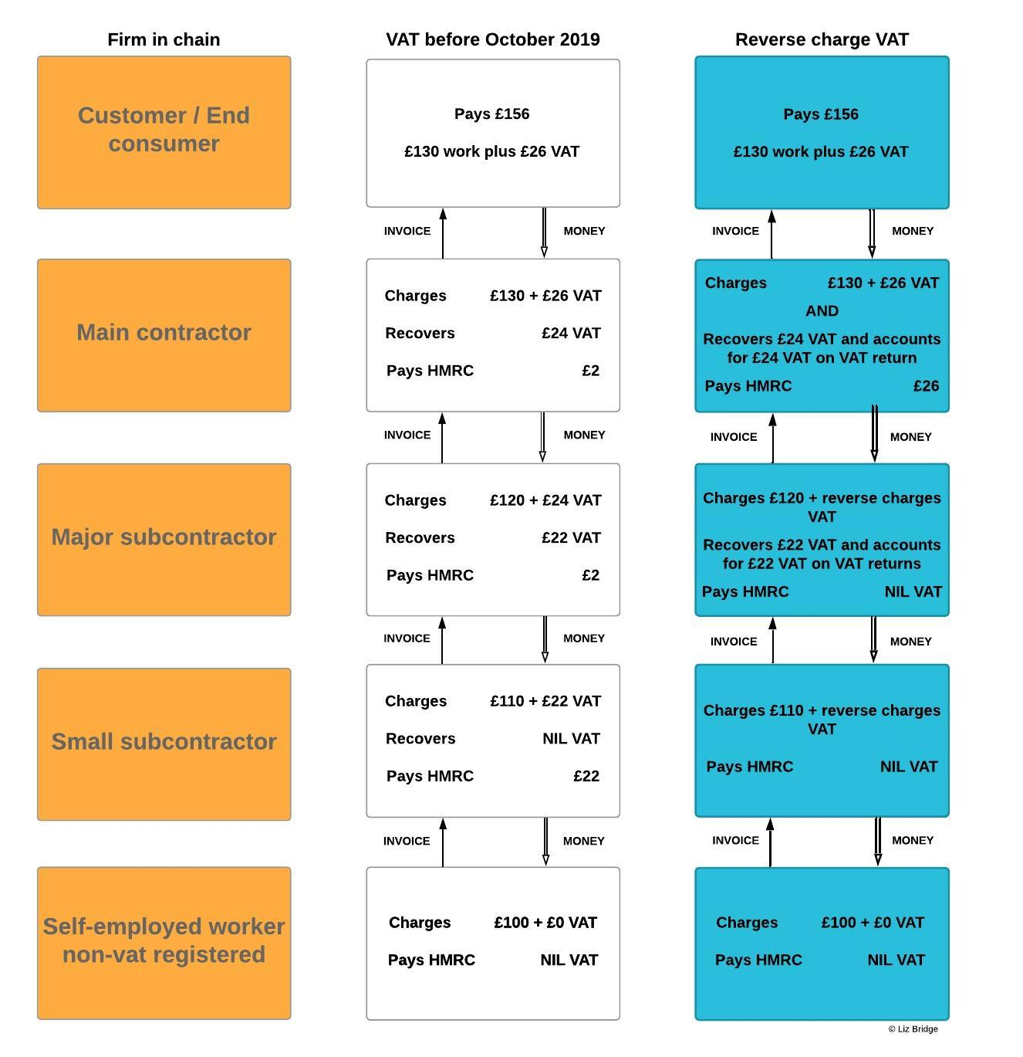

Appendix 2 – definitions & activities
Annex A: HMRC’s core definition of “construction services” – this is the same wording as used for CIS.
a. construction, alteration, repair, extension, demolition or dismantling of buildings or structures (whether permanent or not), including offshore installations;
b. construction, alteration, repair, extension or demolition of any works forming, or to form, part of the land, including (in particular) walls, roadworks, powerlines, electronic communications apparatus, aircraft runways, docks and harbours, railways, inland waterways, pipelines, reservoirs, water-mains, wells, sewers, industrial plant and installations for purposes of land drainage, coast protection or defence;
c. installation in any building or structure of systems of heating, lighting, air-conditioning, ventilation, power supply, drainage, sanitation, water supply or fire protection;
d. internal cleaning of buildings and structures, so far as carried out in the course of their construction, alteration, repair, extension or restoration;
e. painting or decorating the internal or external surfaces of any building or structure;
f. services which form an integral part of, or are preparatory to, or are for rendering complete, the services described in paragraphs (a) to (e), including site clearance, earth-moving, excavation, tunnelling and boring, laying of foundations, erection of scaffolding, site restoration, landscaping and the provision of roadways and other access works.

Annex B: This is HMRC’s list of activities which are NOT in themselves construction services, but are treated as construction services if they are provided in a package with services listed in Annex A.
a. drilling for, or extraction of, oil or natural gas;
b. extraction (whether by underground or surface working) of minerals and tunnelling or boring, or construction of underground works, for this purpose;
c. manufacture of building or engineering components or equipment, materials, plant or machinery, or delivery of any of these things to site;
d. manufacture of components for systems of heating, lighting, air-conditioning, ventilation, power supply, drainage, sanitation, water supply or fire protection, or delivery of any of these things to site;
e. the professional work of architects or surveyors, or of consultants in building, engineering, interior or exterior decoration or in the laying-out of landscape;
f. the making, installation and repair of artistic works, being sculptures, murals and other works, which are wholly artistic in nature;
g. signwriting and erecting, installing and repairing signboards and advertisements;
h. the installation of seating, blinds and shutters;
i. the installation of security systems, including burglar alarms, closed circuit television and public address systems.

The terms used in A & B above are explained in more detail in HMRC’s CIS guide 340
Appendix 3 - Sending out the correct invoice? Normal or reverse charge?
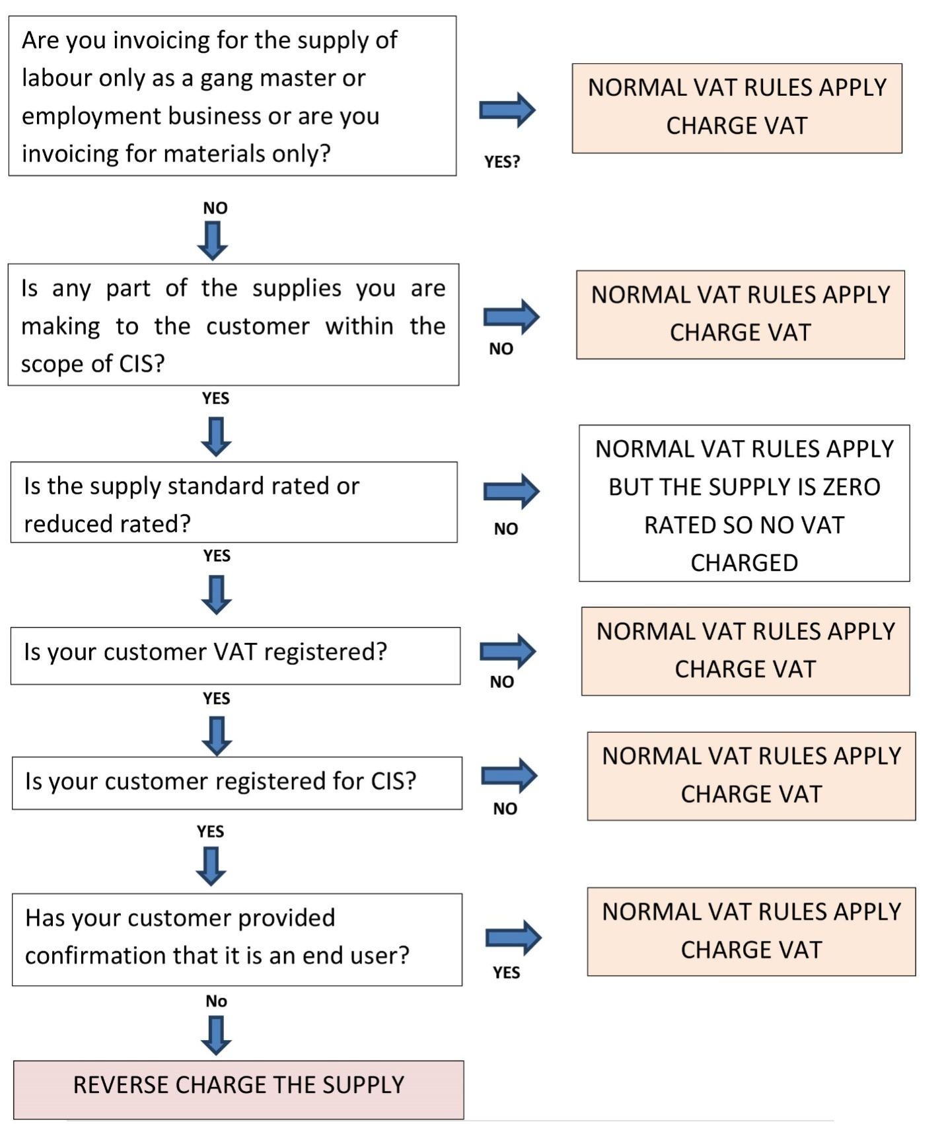

Appendix 4 - Checking an incoming invoice
This chart is to help businesses receiving an invoice or an application for payment to check whether it is correct in charging VAT or reverse charging.
